COUPON CARDS ARE HERE!!!
$20 each
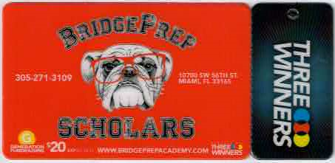
Help us fundraise while you save.

Stop by the main office or see your homeroom teacher.

